Name: | ___________________________________________________ |  |  | Date: ___________
 | Year 11 Applications  Test 2, 2015  Topics – Wages & budgets, Pythagoras, Perimeter, Area, Surface Area & Volume |  |  | 55  = %
Total Time: | 60 minutes | SOLUTIONS
Total Reading: | 5 minutes
Total Working: | 55 minutes
Weighting: | 15% of the semester
Equipment: | SCSA Formula Sheet; ½ page notes (A4 one side), CAS calculator; Scientific Calculator
SECTION 1: CALCULATOR FREE
Time: | 22 minutes | Marks for Section 1: | 20
Reading: | 2 minutes | Equipment Allowed: | Nil
Working: | 20 minutes

1. | [2 marks]
A real estate agent charges the following commission for selling properties:
- 10% for the first $80 000
- 5% for the next $50 000
- 1% for the remaining amount
 | What commission will the real estate agent earn for selling an apartment for $120 000?
120 000 – 80 000 = 40 000
  - × 80 000 + 0.05 × 40 000 = 8000 + 2000 = 10 000

2. | [2 marks]
Daniel works at Masters Warehouse and earns an hourly rate of $10 per hour. If Daniel works the following shifts what will be his gross wage for this week?

- Monday 4.5 hours
- Tuesday 6 hours
- Wednesday 5 hours
- Thursday 8 hours
- Friday 6.5 hours
Total hours = 4.5 + 6 + 5 + 8 + 6.5 = 30
Wage = 30 × $10 = $300

3. | [2 marks]
 | Determine whether the following triangle is a right angle triangle and give mathematical reasons for your conclusion.
A

4cm 8cm

B 6cm C

Pythagoras states in any right angle triangle sum of the squares of the shorter two sides is equal to the square of the hypotenuse therefore:
8 × 8 = 64
4 × 4 + 6 × 6 = 16 + 36 = 52
As Pythagoras doesn’t apply triangle ABC is not a right angle triangle.

4. | [2 marks: 1, 1]
 | Calculate the perimeter of the following shapes:
a) | 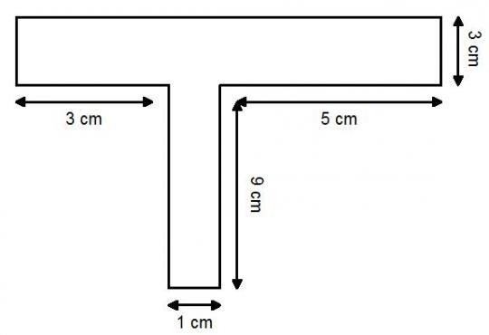 | b) | 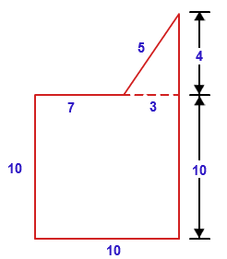
 | Perimeter = 3 + 9 + 1 + 9 + 5 + 3 + 9 + 3  = 42 |  | Perimeter = 10 + 10 + 10 + 7 + 5 + 4  = 46

5. | [4 marks: 1 mark each]
 | Convert the following measurements into the units specified:
a) | 525000 cm = 5.25 km | b) | 0.025 km = 25 m
c) | 50m² = 500000 cm² |  | 2500mm² = 250000 cm²

6. | [4 marks: 1, 2, 1]
 | Calculate the area of the following shapes:
a) | 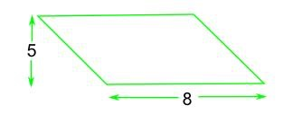 | b) | 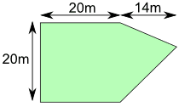
 | Area = 5 × 8 = 40 units² |  | Area = 20 × 20 + ½ × 20 × 14 = 540 m²
c) | 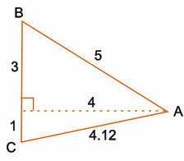
 | Area = ½ × 4 × 4 = 8 units²

7. | [2 marks]
 | Calculate the volume of the following shape:
 | 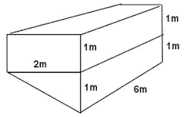 Volume = 2 × 1 × 6 + ½ × 2 × 1 × 6 = 18 m³

8. | [2 marks]
 | If the volume of a cube is 27cm³, what is the surface area of the cube? (Show all working)
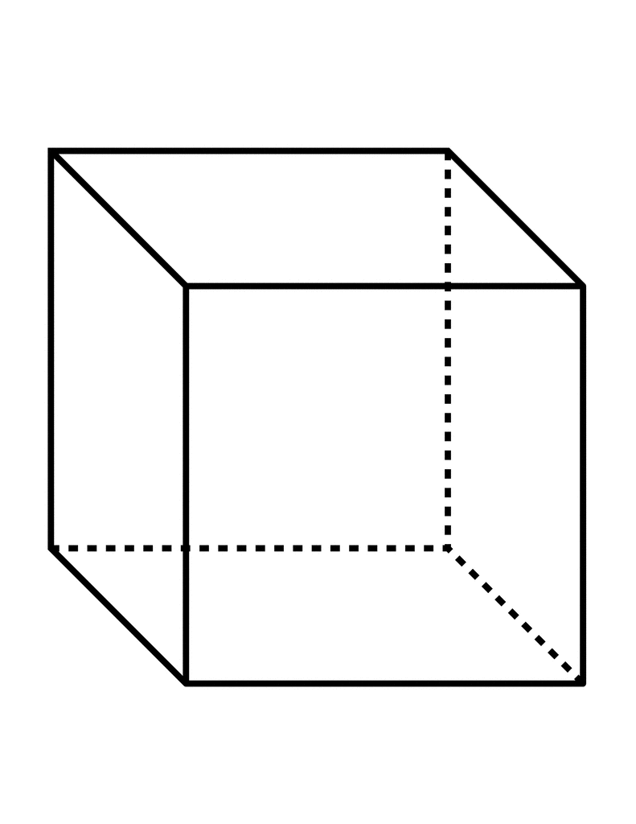 Volume = s × s × s = 27 so s = 3 cm
SA = 6 × 3 × 3 = 54 cm²

~ END OF TEST SECTION 1 ~

Name: |  |  |  | Date: ___________
SECTION 2: CALCULATOR ASSUMED
Time: | 38 minutes | Marks for Section 2: | 35
Reading: | 3 minutes | Equipment Allowed: | ½ page notes (A4 one side),  CAS calculator
Working: | 35 minutes

9. | [2 marks]
 | Firemen have a 10m ladder and they are unable to get closer than 5m from the base of a building due to obstructions. Will the ladder be longer enough to reach a window that is 8.5m high? (Show all working)
 | 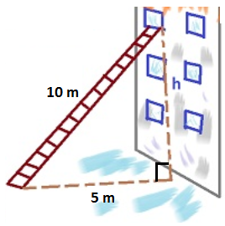 | The ladder will be long enough to reach the window

10. | [4 marks: 2, 2]
 | Calculate the area of the following shapes:
a) | 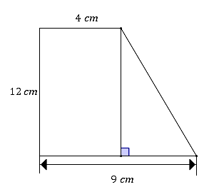 | b) | 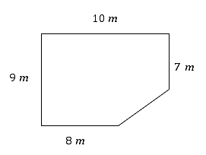
 | Area = 12 × 4 + ½ × 5 × 12  = 78 cm² |  | Area = 9 × 8 + 2 × 7 + ½ × 2 × 2  = 88 m²

11. | [3 marks]
 | In the diagram below, the roof has a height of 3 metres. Find the surface area of the figure shown to 2 decimal places. (Show all working)
 | 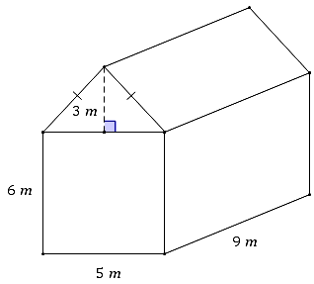 | Slant height =  SA = 2 × 5 × 6 + 2 × 9 × 6 + 9 × 5 + 2 × ½ × 3 × 5 + 2 × 3.91 × 9  SA = 298.29 m²

12. | [7 marks: 1, 1, 2, 3]
 | Find the volume of the following shapes.
a) | 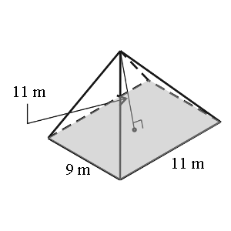 | b) | 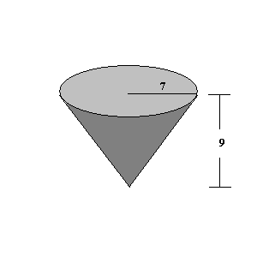
 | Volume = ⅓ × 9 × 11 × 11 = 363 m² |  | Volume = ⅓ × π × 7 × 7 × 9 = 461.81 units³
c) | 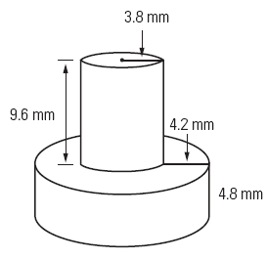 | d) | 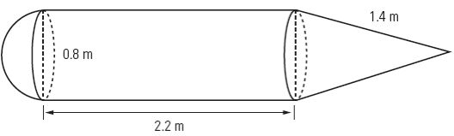
 | Volume = π × 3.8² × 9.6 + π × 8² × 4.8  = 1400.60 mm³ (2 d.p.) | Height of cone:  Volume = 1.46 m³

13. | [2 marks: 1, 1]
a) | Dayna picks apples to earn some extra cash during her holidays. If Dayna is paid at a rate of 25 cents per kg of apples she picks, how much will she earn if she has picked 120.5kg?
Pay = 120.5 × 0.25
= $30.13

b) | A sports agent received $1500 as his commission on an appearance fee for one of his clients. If the sports star received $125 000 as his appearance fee, what percentage commission did the agent receive?
 | Percentage Commission = 1500 ÷ 125 000 × 100 = 1.2%

14. | [4 marks: 2, 1, 1]
 | A swimming instructor is paid $18.50 per hour for normal hours and paid time-and-a-half overtime for any hours after 5:00pm and any hours completed on weekends.
Day | Start time | Finish Time | Normal Hours | Overtime Hours
Monday | 10:00am | 1:00pm | 3
Tuesday | 9:30am | 11:30am | 2
Wednesday | 10:30am | 2:00pm | 3.5
Thursday | 11:30am | 6:30pm | 5.5 | 1.5
Friday | 1:00pm | 9:00pm | 4 | 4
Saturday | 11:30am | 2:30pm |  | 3
Sunday | 11:00am | 1:00pm |  | 2

a) | Complete the last two columns of the table
b) | What were the total hours for the week at normal rate of pay and at overtime rate of pay?
 | Normal Hours = 18 ½ Overtime Hours = 10.5 ½
c) | What was the swimming instructor’s total pay for the week?
 | Total Pay = 18 × 18.50 + 1.5 × 18.5 × 10.5 = $624.38

15. | [2 marks:1,1]
a) | Shanaya’s take home salary after tax is $45 850 p.a. If she gets paid fortnightly, how much is her fortnight pay?
 | $45 850 ÷ 26 = $1763.46
b) | Defence personnel living away from their families receive a yearly family separation allowance of $2 560. If a Defence member earns a salary of $95 000 and they qualify for the separation allowance, what would be their weekly pay?
 | Weekly Pay = ($95 000 + $2560) ÷ 26 = $3752.31

16. | [5 marks: 1, 2, 2]
 | Use this Information relating to the Baby Bonus to answer the following questions.
 Baby Bonus
A payment made in 13 fortnightly instalments that helps with the costs of a child who is born or adopted before 1 March 2014. Baby Bonus is payable if your family's estimated combined adjusted taxable income is $75,000 or less in the 6 months after your child is born or enters your care. If you became eligible for Baby Bonus, on or after 1 July 2013, Baby Bonus is either $5,000 or $3,000 depending on your situation. You can get the $5,000 payment if your child is the first child you or your partner have given birth to (excluding stillbirth), adopted, or had entrusted to your care within 26 weeks of birth. Otherwise, you can get the $3,000 payment. If you are eligible for $5,000, you will get $846.20 in the first fortnight and then the remainder in equal instalments over next 12 fortnights. If you are eligible for $3,000, you will get $692.40 in the first fortnight and the remainder in equal instalments over the next 12 fortnights.

a) | A couple apply for the baby bonus, it’s their first child and their combined income is $85 000. Will they receive a baby bonus?
 | No they earn too much
b) | Another family are celebrating the arrival of their second child and they are eligible for the Baby bonus. How much will they receive and what will be their fortnightly payments?
 | $3000 in a first installment of $692.40 then $192.30 per fortnight
c) | A young couple are having their first child. The father’s income was $42 000 over the last 6 months and the mother earned $15 500. Are they eligible for the bonus and if so how much in total will they receive?
$42 000 + $15 500 = $57 500

This is under the $75 000 so they will get the $5000 bonus

17. | [6 marks: 1, 1, 1, 3]
 | Courtney bought 120 Facebook Inc. stock shares at $65.80 per share.
a) | How much did this cost her?
 | 120 × $65.80 = $7896
b) | Her broker charges a commission of 1.5% of the total sales. Calculate how much brokerage Courtney paid.
 | Brokerage = 0.015 × $7896 = $118.44
c) | In the first year Facebook paid a dividend of 45c per share and in the second year they paid a dividend of 55c per share. Calculate Courtney’s total dividend payment for the two years.
 | Total Dividend = 0.45 × 120 + 0.55 × 120 = $120
d) | Courtney decides to sell her shares after two years for $60 per share. If her broker charges another 1.5% brokerage, calculate Courtney’s total profit or loss over the two year period.
Selling price = 60 × 120 = $7200 ½
Brokerage = 0.015 × 7200 =$108 ½
Total costs = 7896 + 118.44 + 108 = $8122.44 ½
Earnings = 7200 + 120 = $7320 ½
Total earnings = earnings – total cost = 7320 – 8122.44 = −$802.44 ½
Loss of $802.44 ½
~ END OF TEST SECTION 2 ~

